Installing and Running Ruby on Rails 5: Windows
Install Ruby on Rails
Ruby on Rails requires that we use Ruby version 2.2.5 or higher

Once installed –
Open command prompt

irb
puts Ruby in interactive mode
quit
Returns to command prompt

Ruby DevKit
From RubyInstaller.org – choose 64 bit version
Command Prompt – cd \(folder you extracted DevKit to)
ruby dk.rb init
Installs Ruby DevKit and creates file config.yml
type config.yml
Shows the contents of config.yml
ruby dk.rb install
Installs the Ruby Development Kit

Ruby Gems
RubyGems help us to manage the different Ruby libraries that we'll be needing. RubyGems is the name of the package manager. A single RubyGem or just a gem for short is simply Ruby code which has been packaged up for easy distribution using the RubyGem package manager. Rails makes extensive use of RubyGems, and is itself in fact a gem. RubyGems are included in the Ruby installer, so it should've installed RubyGems for us at the same time that it installed Ruby.

Gem list
Will list the currently installed Ruby Gems

gem update --system
Finds any update for gems – run periodically

Ruby on Rails
Rails is both a library of Ruby code that can power our web applications, but it's also a small program that helps us to interface with that library of Ruby code from the command line.
rails -v
Rails 5.0.0. Now we have Rails and all of the libraries that it needs installed

MySQL
Install using MySQL Community Edition at https://www.mysql.com/downloads/

MySQL Ruby GEM
The MySQL RubyGem contains the code which allows Ruby to communicate with the MySQL server. It will serve as the conduit from our Rails application to our back-end database.

Go to rubygems.org
Search for mySQL
Don't use the exact match shown at top – scroll down to find mysql2 – you can use this link to find information about the mysql2 gem
To install the mysql2 gem
go to command prompt
gem install mysql2
Ruby will go out and ask it for the latest version of the mysql2 gem, bring back data about that, and then it's going to compile the code that we need into C, using the C compiler in order to compile that code

Web Server
Ruby on Rails doesn't interface with the internet on its own, so we need something that's going to take a request from a user, when they type in a URL, it's going to send it to our Rails application, our Rails application will then return a result to the web server, which then gets sent back to the user. A web server is an essential part of this process, and we have a few different options.

From Lynda.com lesson:
“There are a lot of heavy duty web servers, Apache, NGINX, Passenger, Unicorn
They're great for deploying and putting them on production, but when we're developing, we really just want something that's going to deliver a lot of speed to us, that's just going to be really fast and lightweight, because there's really only one request that's coming in to our Rails application, us, the developer. It's not like we have thousands of people submitting requests simultaneously to our application yet. So there's really just one person, we need something very simple, so in the past, Ruby on Rails used WEBrick.
WEBrick was a really simple basic web server. I think it actually shipped with Ruby. I think it was just a fundamental part of Ruby, and it was great. It was really nice and simple, and got the job done, but in Ruby on Rails 5, that changed. So for the first time, instead of using WEBrick, we're going to be using Puma. Puma's going to be built in to any new Rails 5 project automatically. It's going to be something that gets loaded in as a gem when we start up the project, and it will run in the background. And it runs almost exactly the same way WEBrick did, so you wouldn't really notice a difference except that you may notice in your log files that it just says Puma sometimes instead of WEBrick.

So, it's going to be pretty seamless. Why the change, then? Well Puma allows multi-threaded requests. It allows threads and concurrency in a way that WEBrick didn't, and that's one of the features of Ruby on Rails 5, is that it has a lot of those things baked into it, so we need a slightly more sophisticated web server than what WEBrick provided. Puma, incidentally, can be used in production, as well. It is a replacement for Passenger or Unicorn, so you can use Puma with something like NGINX or Apache on the front end, and a lot of people have started doing that, as well.
But Puma is going to be the preferred web server for working with Ruby on Rails 5. As I said, there's nothing we need to do to install it. It'll automatically be there for us, you just need to be aware of it.

Text Editor
Atom or Brackets

Run Ruby on Rails
Create a New Project
Projects are stored at C:\Users\JMS2\Documents\RubyProjects\sites
The way we create our Ruby on Rails project is using the rails command. Rails, followed by a space, and then new, for creating a new project, and then a space, and then the name of the project, with no spaces.

Rails new demo_project -d mysql

This will create all the folders and files for the project an configure the project for mysql access

Configure the database
Create the database from the MySQL command line

MySQL create, space, database command, and then, we have to give it the name of the database we want to create. By convention, in Rails projects, you want to use the same name for the database as you have for the project, so demo_project.

create database demo_project_development;
Then create another for testing
create database demo_project_test;

There are actually three typical environments that we use in Ruby on Rails - the development environment, the test environment, and the production environment.

Create a user
grant all privileges on demo_project_development.* to 'rails_user'@'localhost' identified by 'jms#rails';
grant all privileges on demo_project_test.* to 'rails_user'@'localhost' identified by 'jms#rails';

Exit mysql

Go back to project and set up database.yml

default: &default
adapter: mysql2
encoding: utf8
pool: 5
username: rails_user
password: jms3172
host: localhost

Note: Rails database access will not work if XAMPP MySQL Service is running – you have to stop that service in XAMPP prior to the next steps. Otherwise you will get and error: Access denied for user from the MySql2 ruby gem
To test the database connection:
rails db:schema:dump
This will create a schema file in the project in the db folder – that file will not exist prior to running this command so its existence afterward will indicate the successful connection to the database created in the MySQL data folder as specified in the Configure the Database section above.

Launch A Project
Now that we've created our Rails project and we've configured it to use a database, we're ready to launch it and view it in a browser. Launching a Rails project really just means telling the Puma web server that it should boot up, grab all the code in your Rails project, and make it available to any web requests that come in from a browser.

Make sure you are in your project folder
rails server
This will launch the Rails server. It boots up Puma by default. And then tells us what version of Rails that we're using. It also tells us that it's opening in development mode. And then it says that we can access this via this URL, HTTP://localhost:3000. 3000 is the port number that it's going to be using and it's an important part of the URL. It's the way that we're going to communicate with Puma. Puma's listening on that port.

Open a browser and enter the URL given by Puma. You should see a web page that indicates that the process worked.

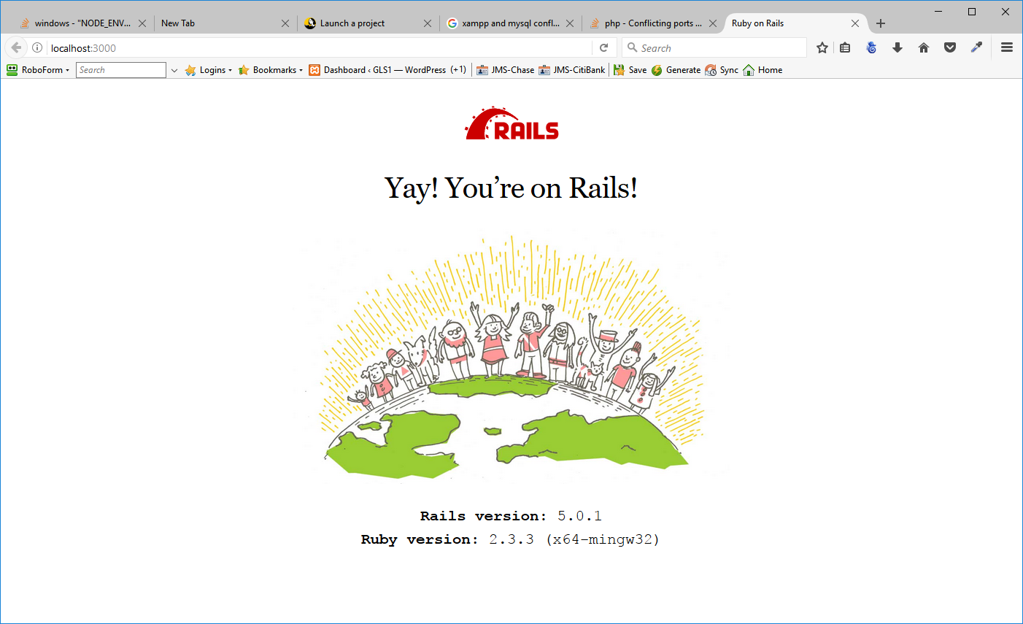
To quit, go back to the command prompt and enter CTRL+C

